**Laboratory -4: Inheritance**

## Task1:

1. There are three (3) classes inside the InheritanceDemo.java (Teacher, Student, and Person).
2. Output was: 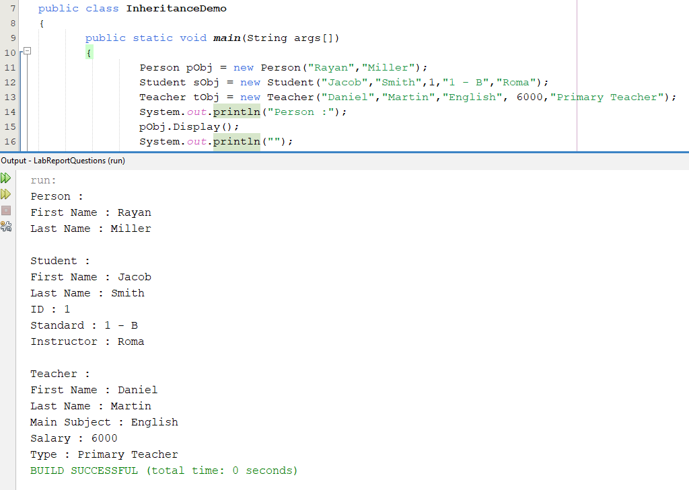
3. In InheritanceDemo.java, an instance of the **Person** class is created and its **Display** method is called to print out the first and last names. This connectivity demonstrates basic class instantiation and method invocation.
4. Teacher class inherits from Person class, adding its own properties (mainSubject, salary, type) and methods (Display), and is instantiated and used in InheritanceDemo class.
5. Student inherits properties and methods from Person, adds its own attributes (id, standard, instructor), and is instantiated and used in InheritanceDemo class.
6. @startuml
   class Person {
     - String FirstName
     - String LastName
     + void Display()
   }

   class Student extends Person {
     - int id
     - String standard
     - String instructor
     + void Display()
   }

   class Teacher extends Person {
     - String mainSubject
     - int salary
     - String type
     + void Display()
   }

   class InheritanceDemo {
     + void main(String[] args)
   }

   InheritanceDemo --> Person : "uses"
   InheritanceDemo --> Student : "uses"
   InheritanceDemo --> Teacher : "uses"
   @endumlUML Diagram (made by PlantUML).
7. Output looks perfect after changing the values: A screenshot of a computer

   Description automatically generated

## Task-2:

1. m2() – method only overridden in the Child class.
2. Differentiate between instance variables and local variables when they share the same name.
3. The super keyword is used to call the constructor of the parent class (Parent.java). When we use super(name) in the Child class constructor, that time the Parent constructor is invoked as a parent class, and the **name** variable is going to properly initialized to the Parent class as well as in the Child class. On the other hand, there is another reason to use the super keyword. Using super avoids duplicating the code that's already in the Parent constructor.

## Task-3:

It is done inside the lab_report project.

## Task-4:

It is done inside the task4 package

Md. Alamin

21303134

Section: A

Semester: Fall-2024